

**CSE302: Database Systems (1)**

**[FALL 2023]**

**Project Report**

Electricity Billing System for DESCO

https://apex.oracle.com/pls/apex/r/alve/electricity-billing-system-for-desco/login?session=12356582775184

**Submitted by:**

|  |  |  |
| --- | --- | --- |
| **Student ID** | **Student Name** | **Contribution Percentage** |
| **2021-3-60-016** | **B M Shahria Alam** | **50%** |
| **2021-3-60-021** | **Tasmiah Rahman Orpa** | **25%** |
| **2021-3-60-048** | **Sidratul Moontaha** | **25%** |

# E-R Model of the Project

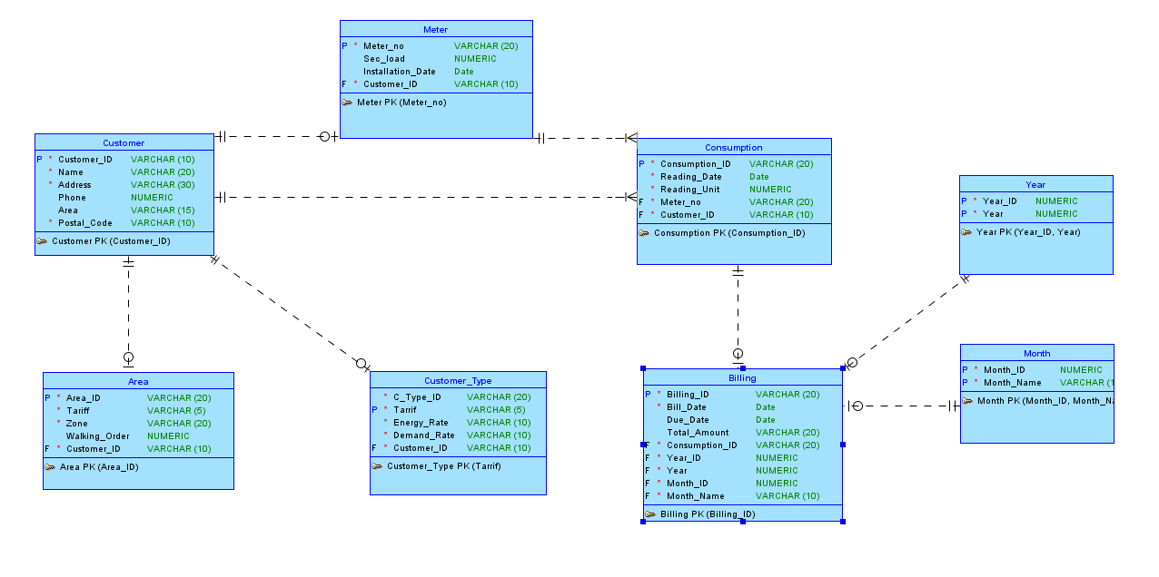

# Relational Data Model of the Project

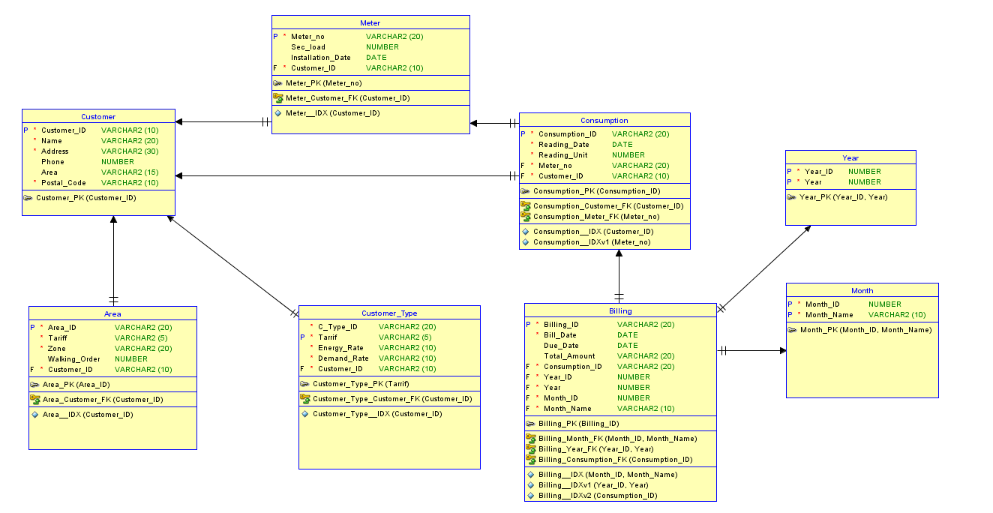

# Implementation Checklist

|  |  |
| --- | --- |
| Description | Remarks |
| Project ID | 176892 |
| Workspace Name | Alve |
| Workspace Email | 2021-3-60-016@std.ewubd.edu |
| Workspace Password | 112225EWU |
|  |  |
| Authentication Type | Custom |
| Username and Password to Login |  |
| ADMIN  GUEST | ADMIN  GUEST |
|  |  |
| Uploaded and Displayed Images in Reports | Yes |
| Implemented Page-wise Authorization | Yes |
|  |  |
| Number of Reports with Forms | 9 |
| Number of Master-detail Forms | 2 |
| Number of Reports based on Queries, Aggregate Queries | 2 |
| Number of Parameterized Reports | 1 |
| Number of Graphs/Charts | 4 |
|  |  |
| Included any trigger/other feature which is not taught in class. If yes, please explain briefly. | Calculate Unit with trigger.  Calculate Total Amount with trigger |
| Write the most unique feature/functionality in your application or the page of your application that you are proud of. Explain briefly. | We have worked with a real database. This is the unique work. |

# Reports with Forms

|  |  |  |
| --- | --- | --- |
| Report Page Number and Name | Form Page Number and Name | Table |
| 11 - Office Info | 10 - Add Office Info | Office |
| 4 - Customer Info | 3 - Add Customer Info | Customer |
| 25 - Type Info | 24 - Add Customer Type | Customer Type |
| 9 – Meter Info | 8 - Add Meter Info | Meter |
| 6 – Area Info | 5 - Add Area Info | Area |
| 28 - Consumption Info | 27 - Add Consumption Info | Consumption |
| 74 - Billing Info | 73 - Add Billing Info | Billing |
| 20 – Month Info | 21 - Add Month Info | Month |
| 22 – Year Info | 23 - Add Year Info | Year |

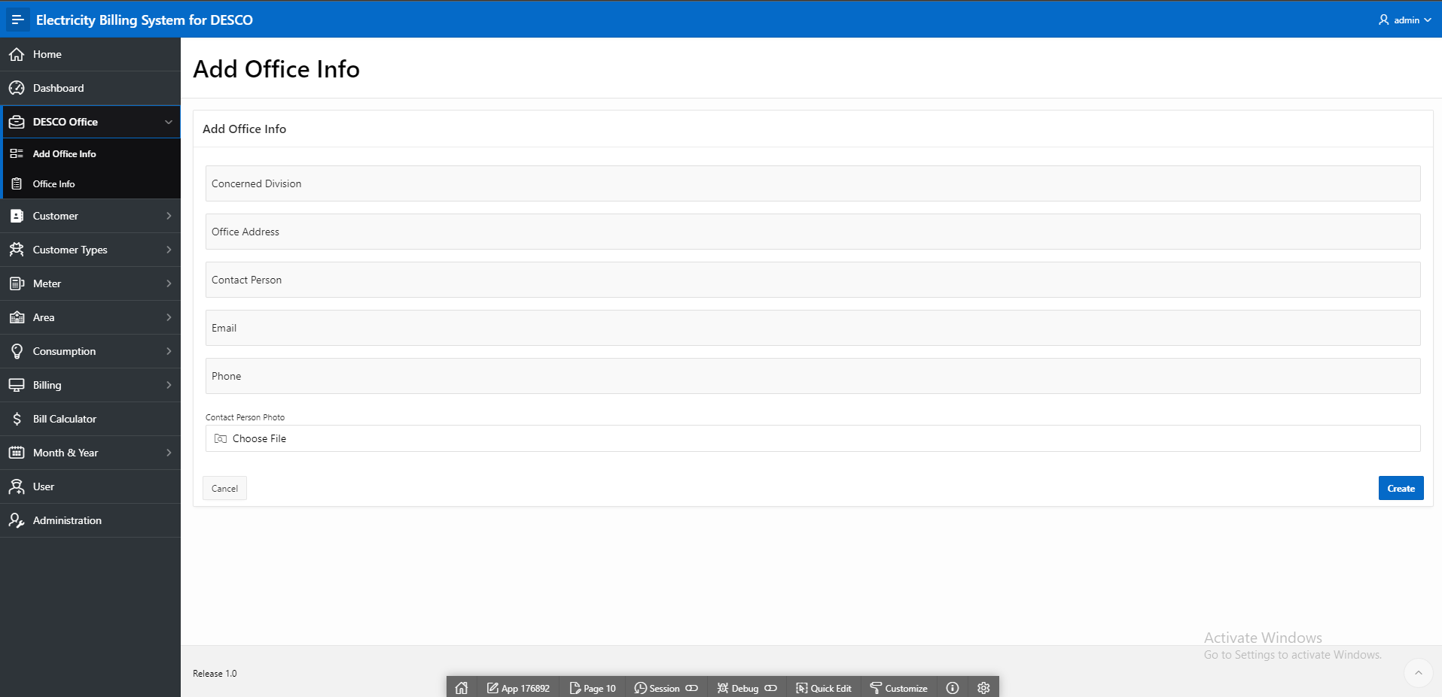

Fig. 4.1: The form to fill the information about Office

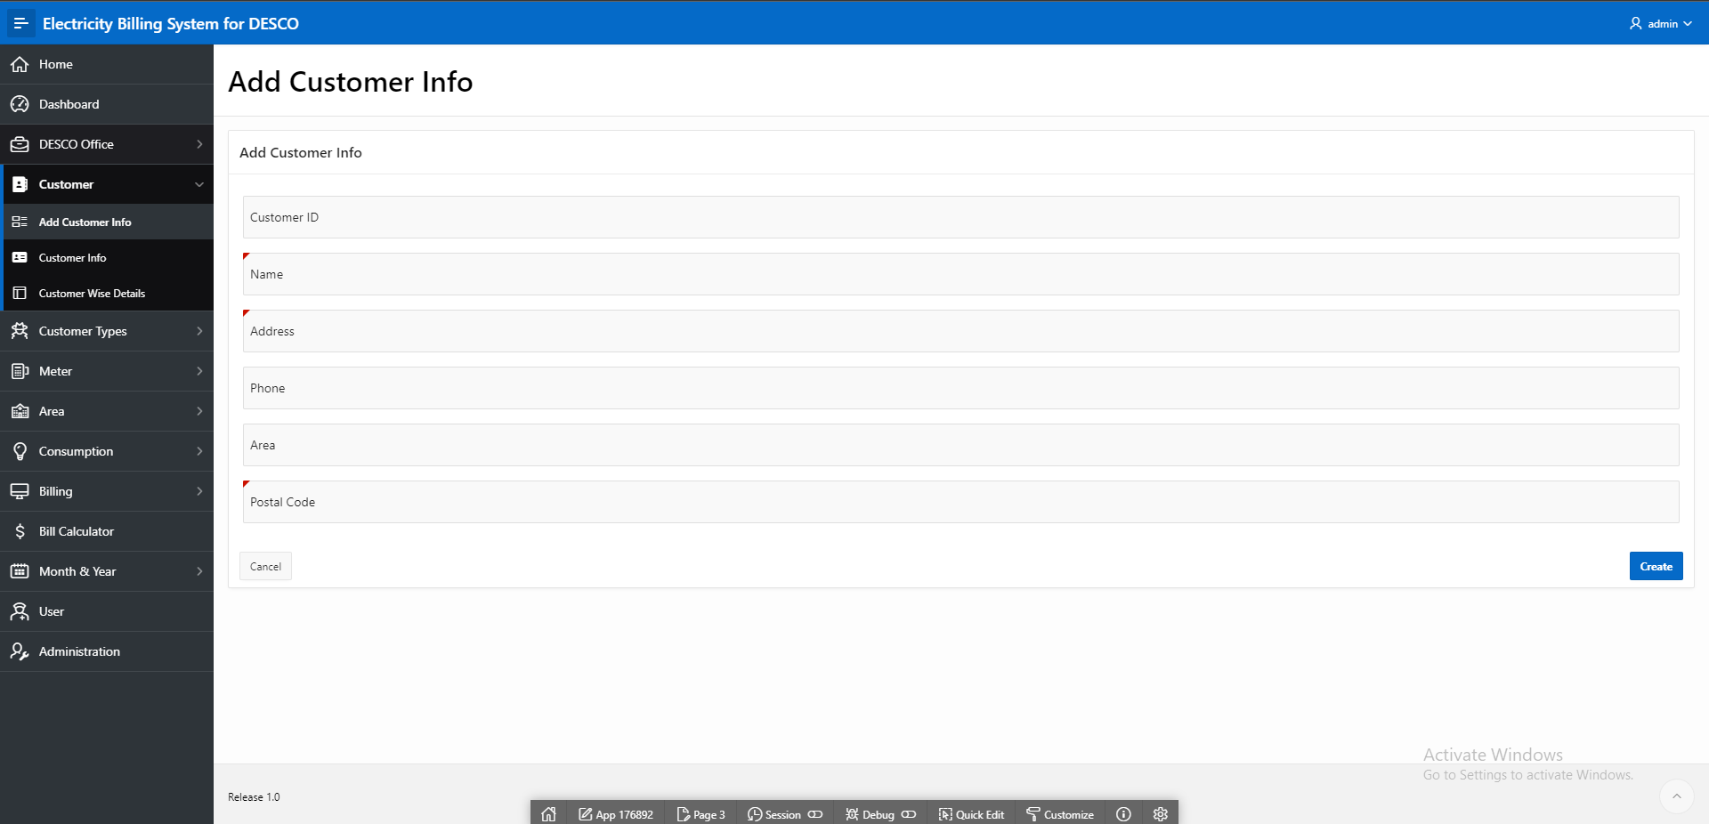

Fig. 4.2: The form to fill the information about Customer

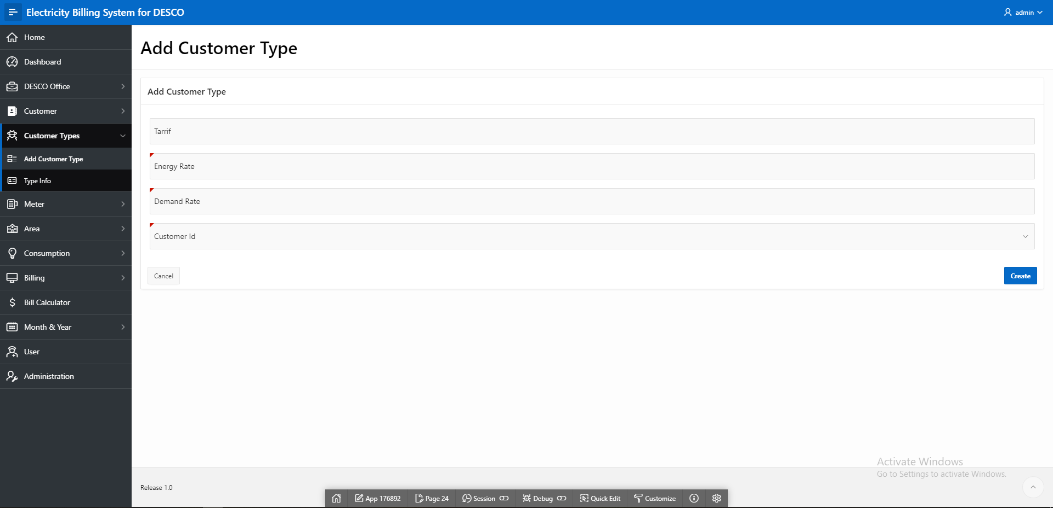

Fig. 4.3: The form to fill the information about Customer Type

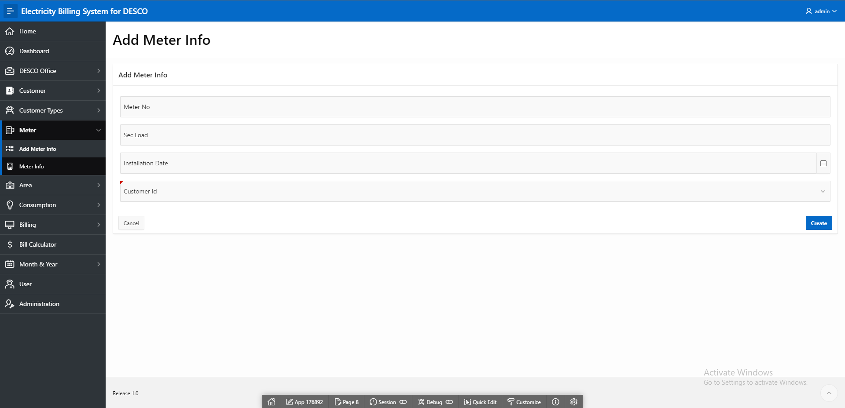

Fig. 4.4: The form to fill the information about Meter

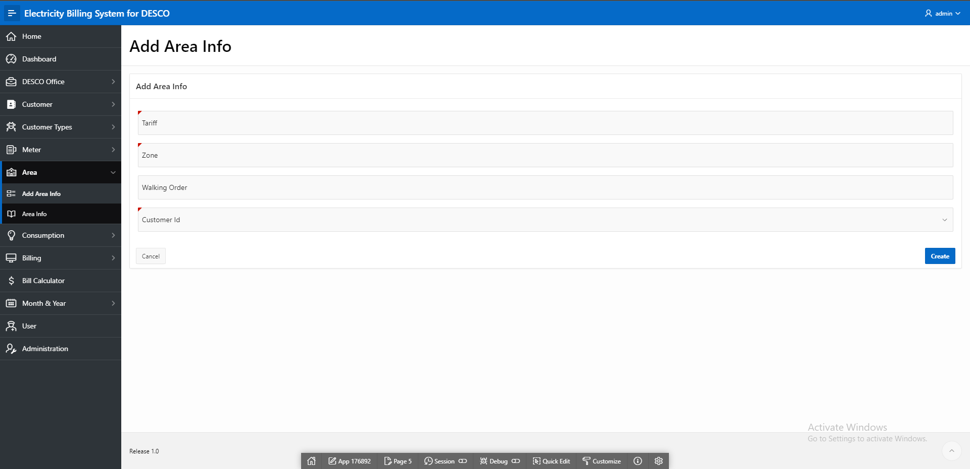

Fig. 4.5: The form to fill the information about Area

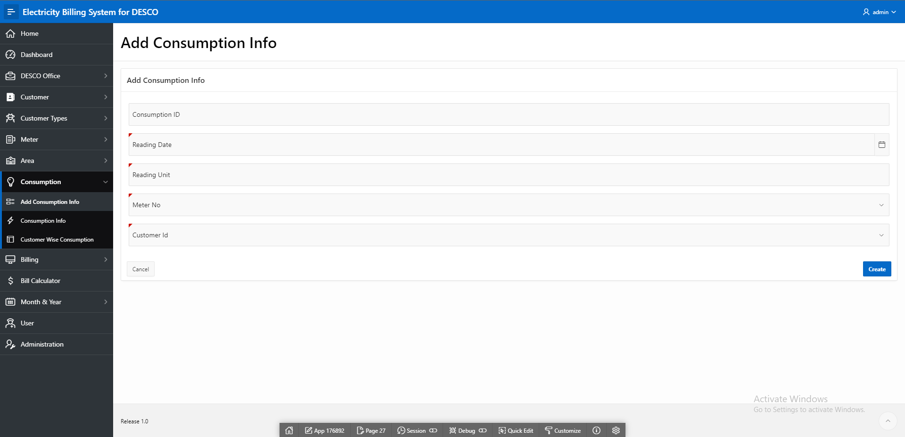

Fig. 4.6: The form to fill the information about Consumption

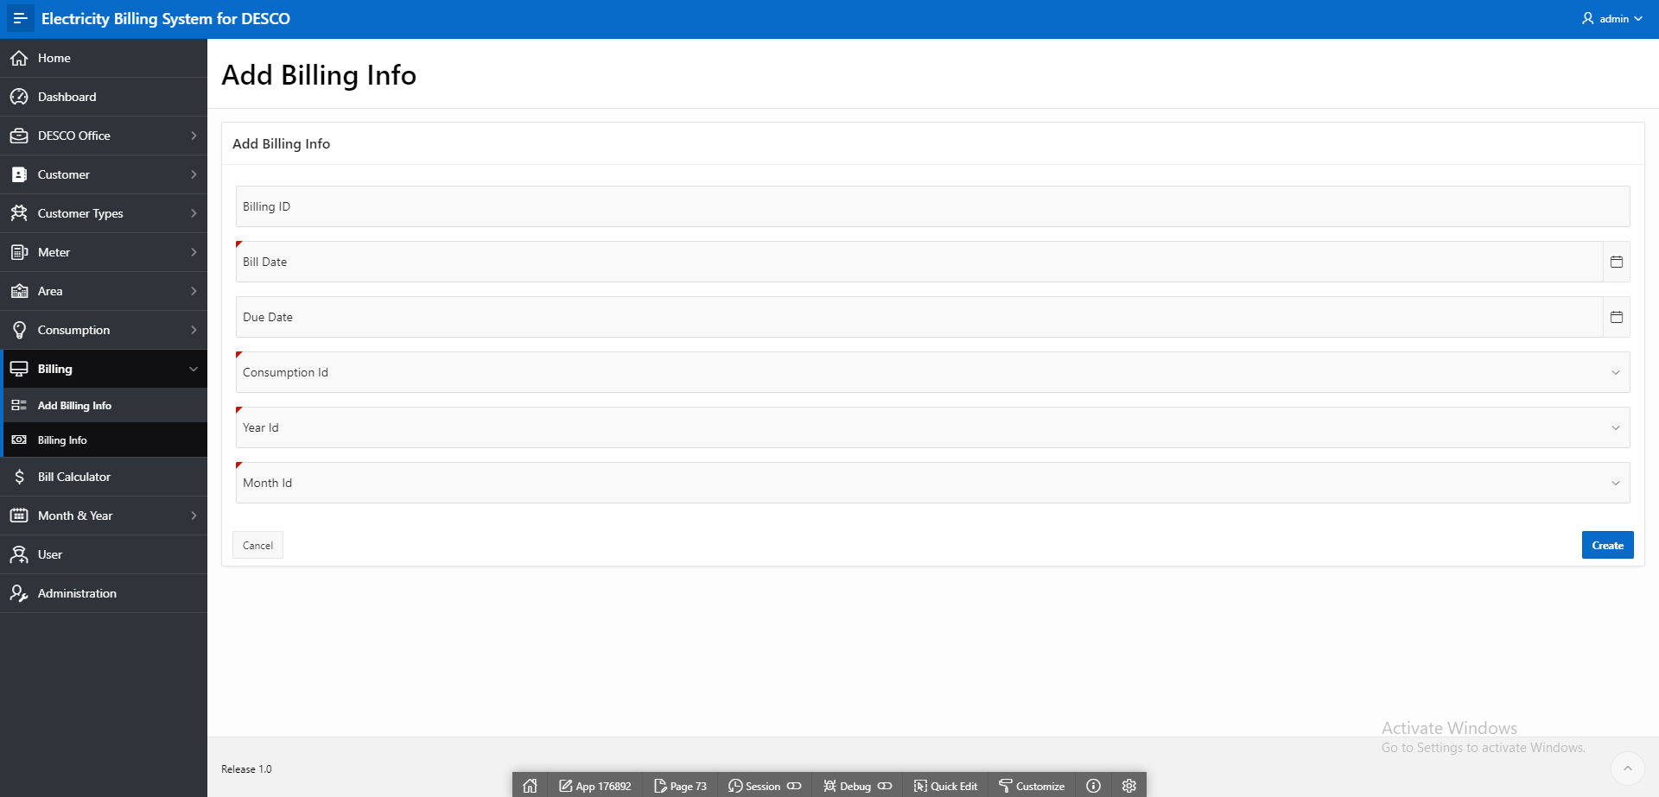

Fig. 4.7: The form to fill the information about Billing

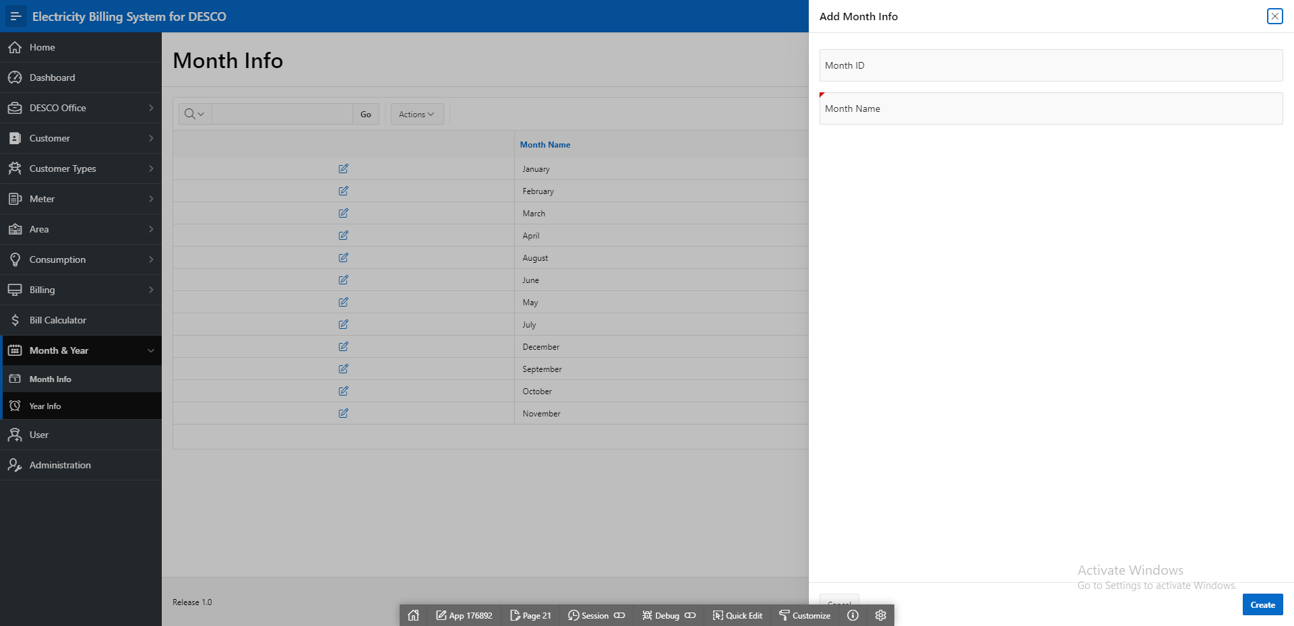

Fig. 4.8: The form to fill the information about Month

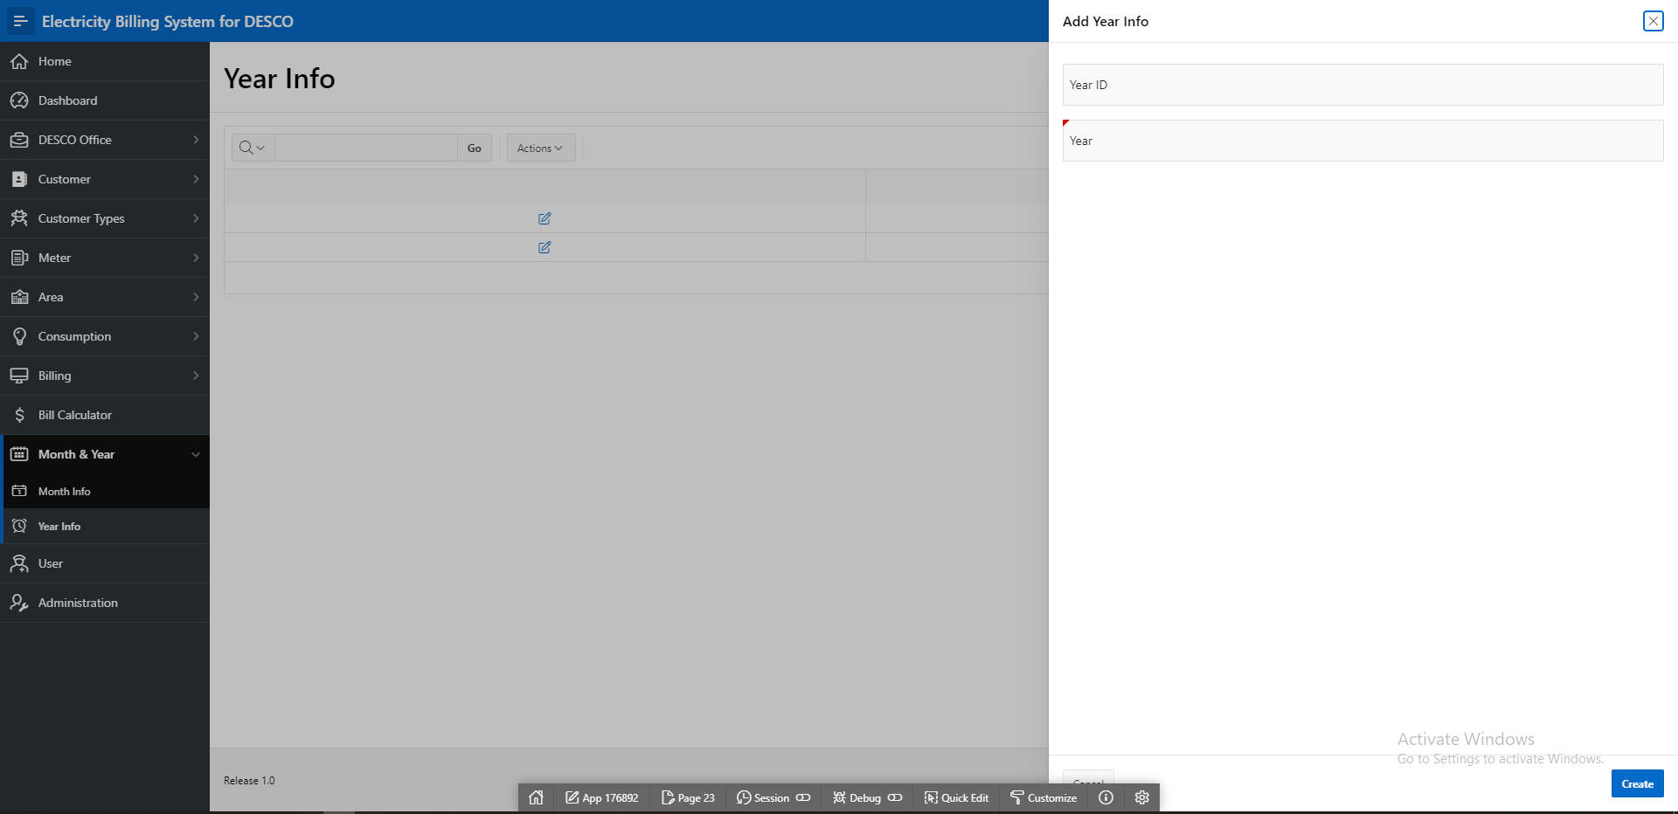

Fig. 4.9: The form to fill the information about Month

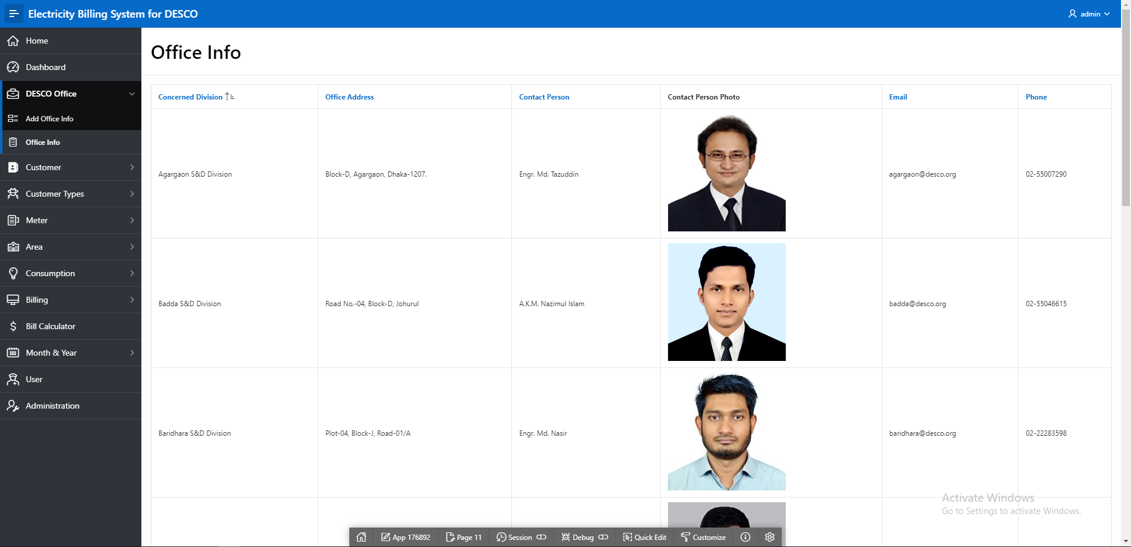

Fig. 4.10: This report contains the information about Office Info

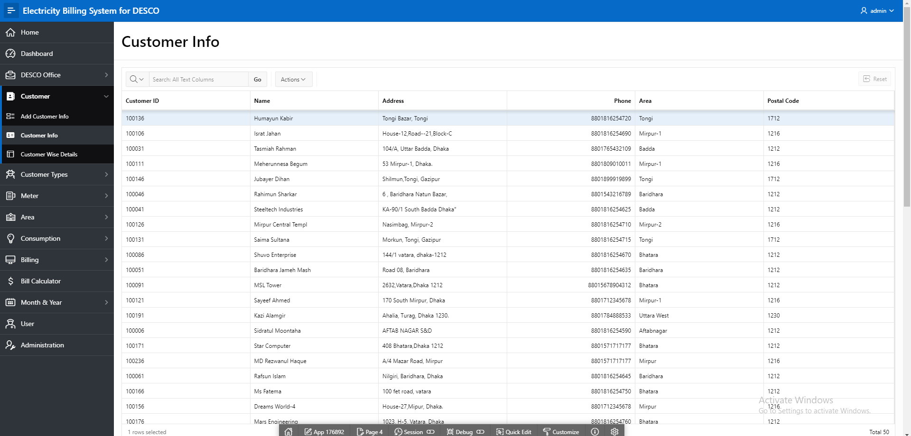

Fig. 4.11: This report contains the information about Customer Info

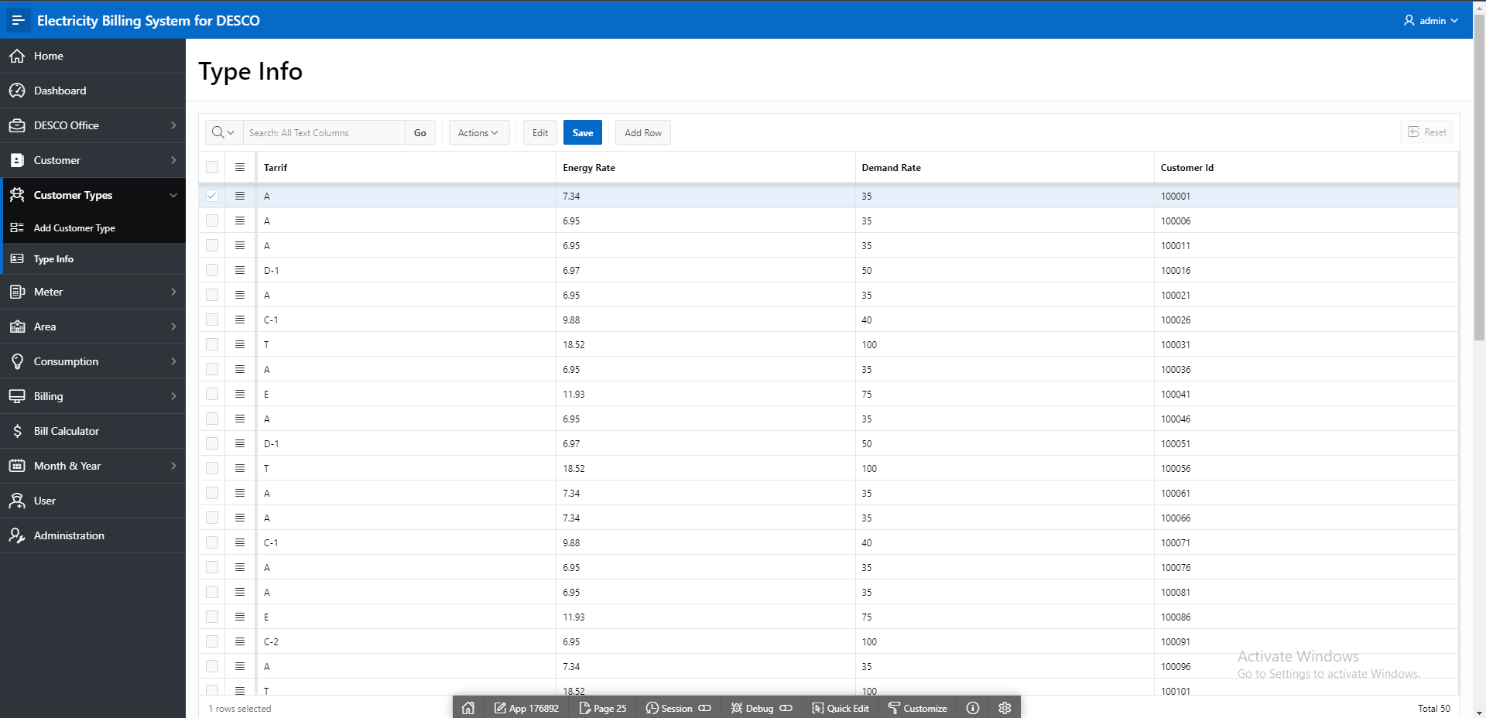

Fig. 4.12: This report contains the information about Type Info

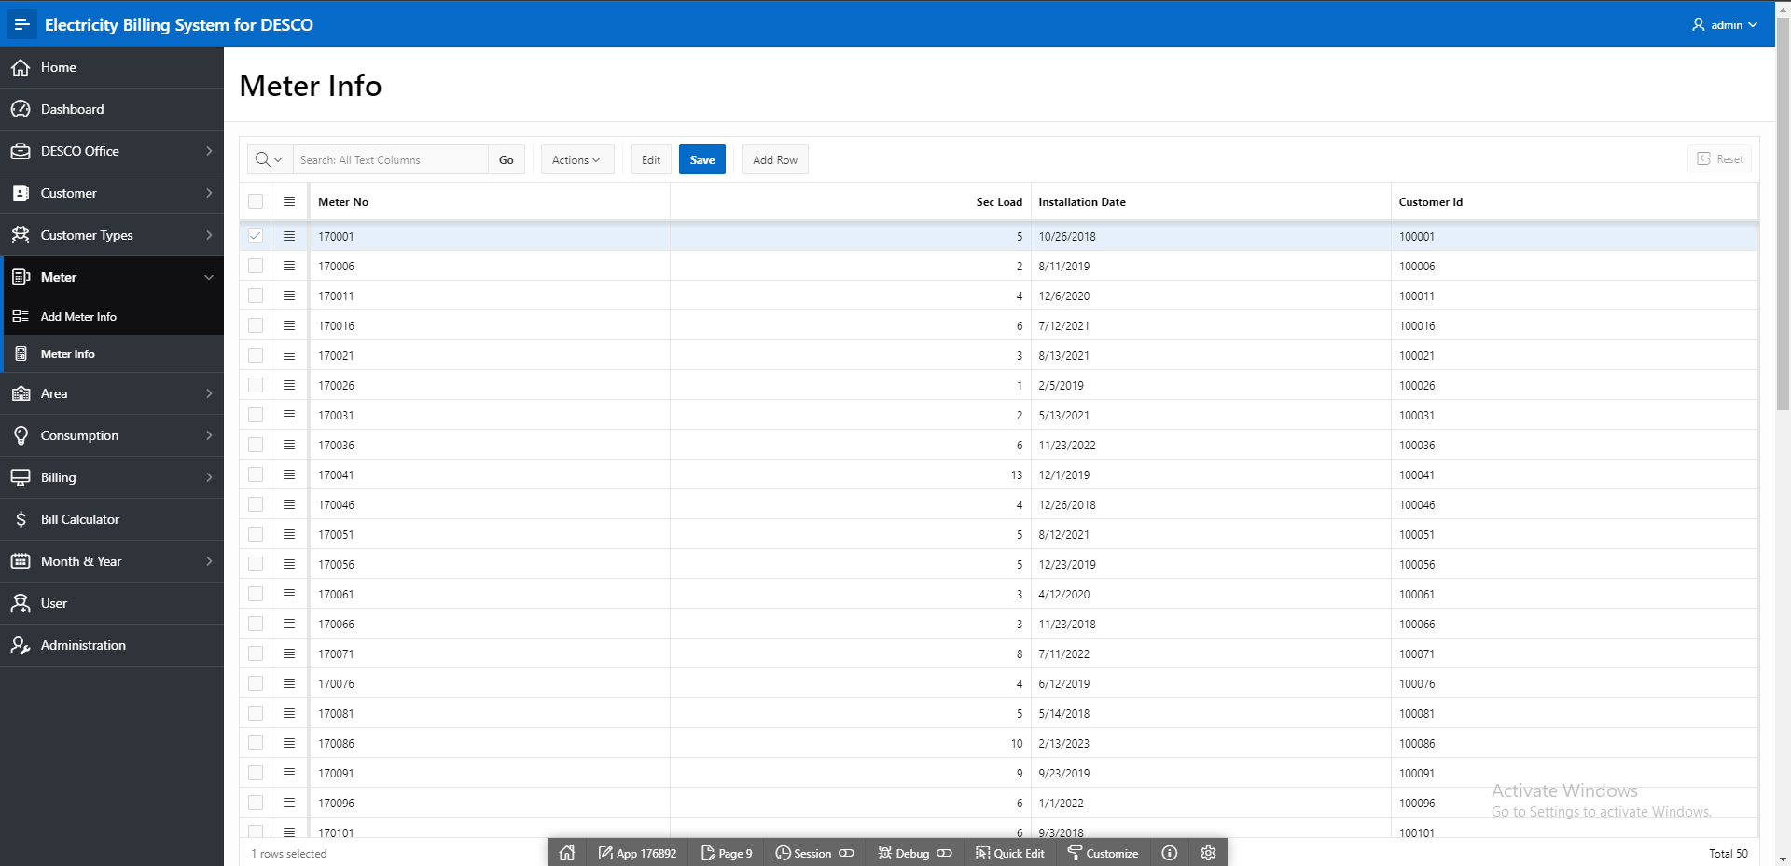

Fig. 4.13: This report contains the information about Meter Info

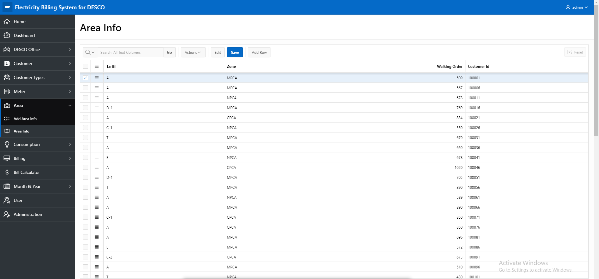

Fig. 4.14: This report contains the information about Area Info

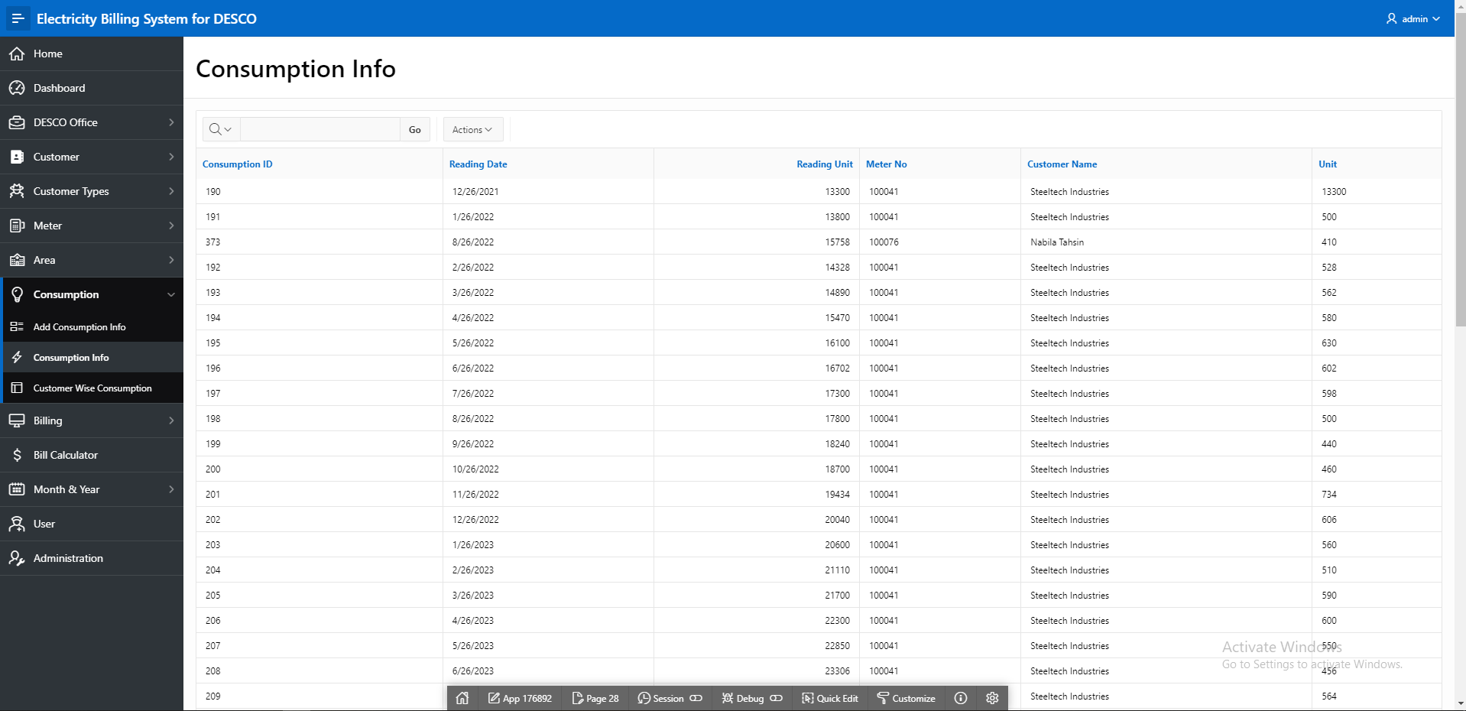

Fig. 4.15: This report contains the information about Consumption Info

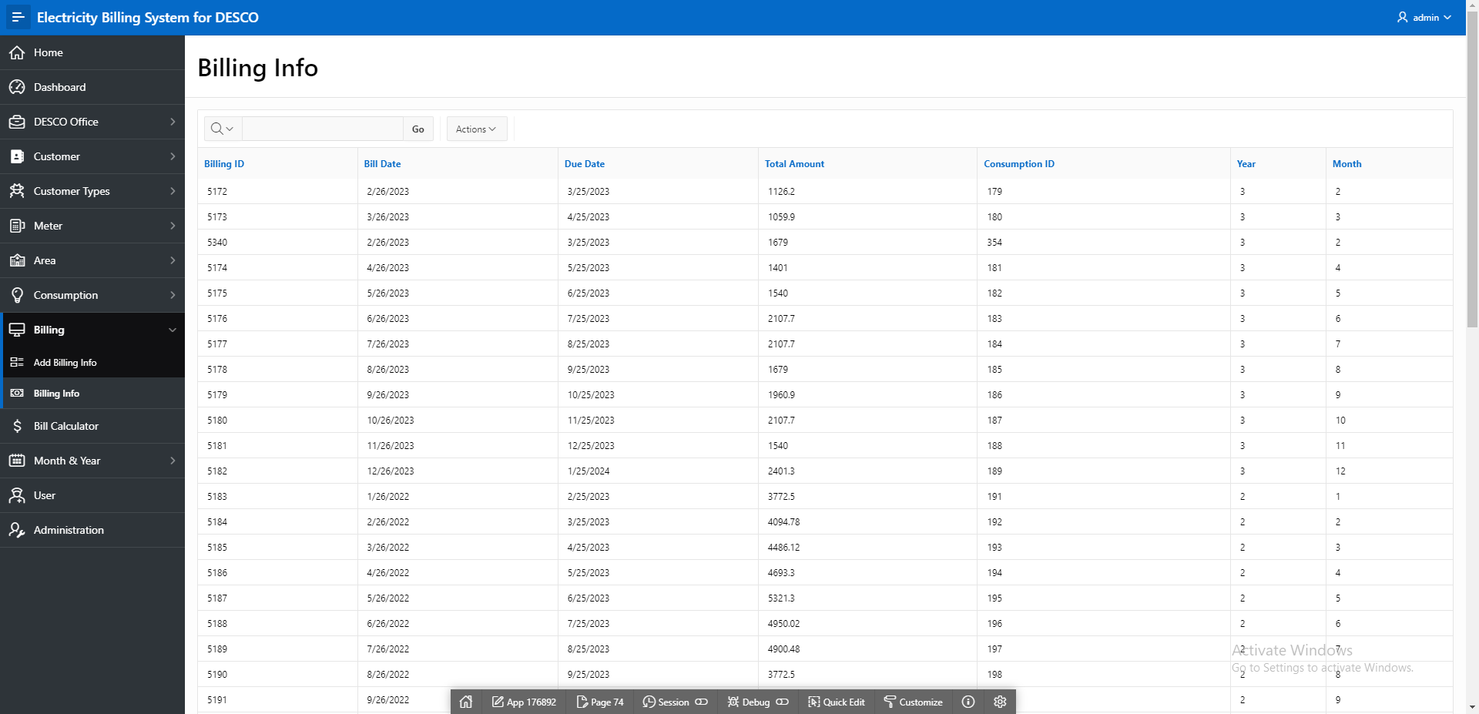

Fig. 4.16: This report contains the information about Billing Info

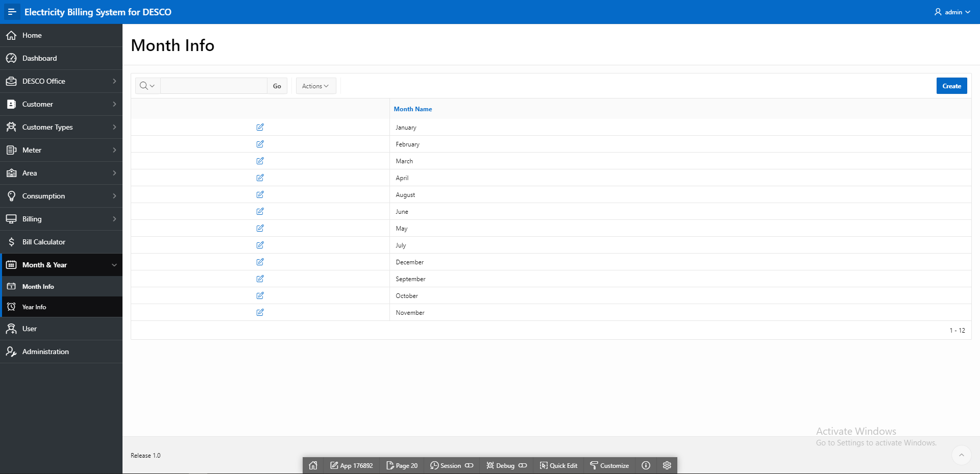

Fig. 4.17: This report contains the information about Month Info

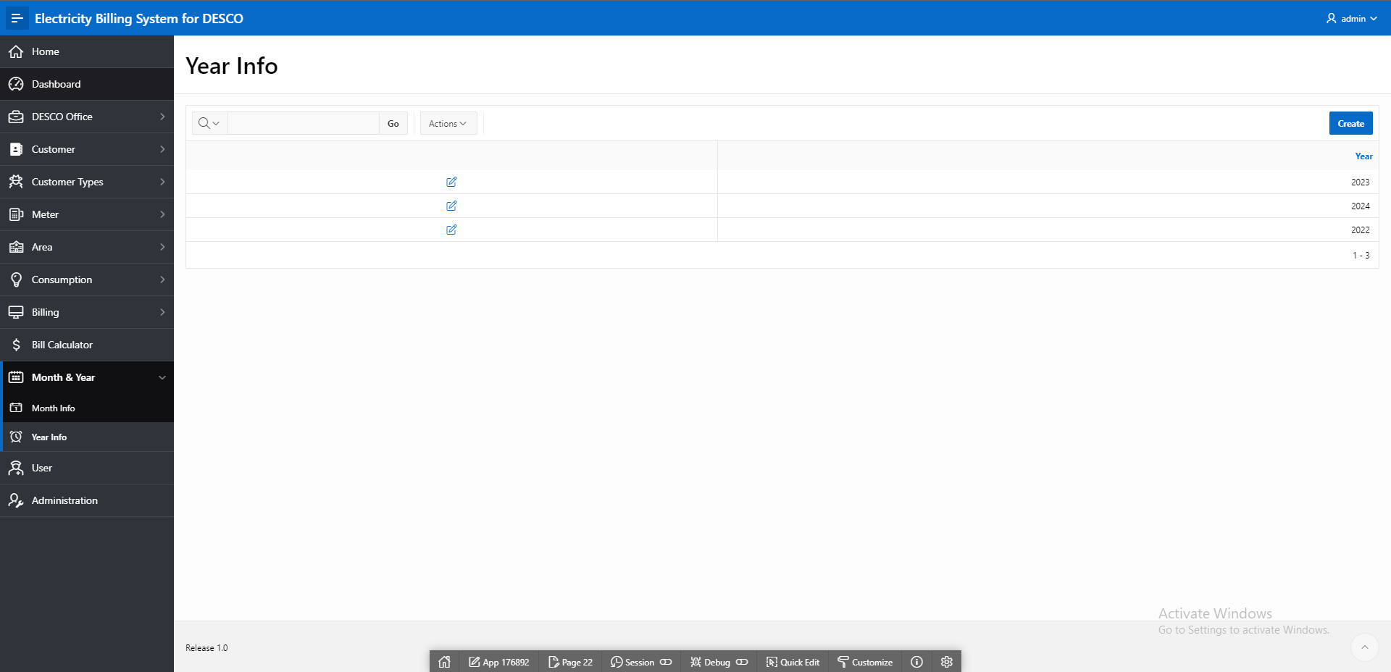

Fig. 4.17: This report contains the information about Year Info

# Master-Detail Form

|  |  |  |
| --- | --- | --- |
| Page Number and Name | Master Table (Parent) | Detail Table (Child) |
| 75- Customer Wise Details | Customer | Area |
| 94 - Customer Wise Consumption | Customer | Consumption |

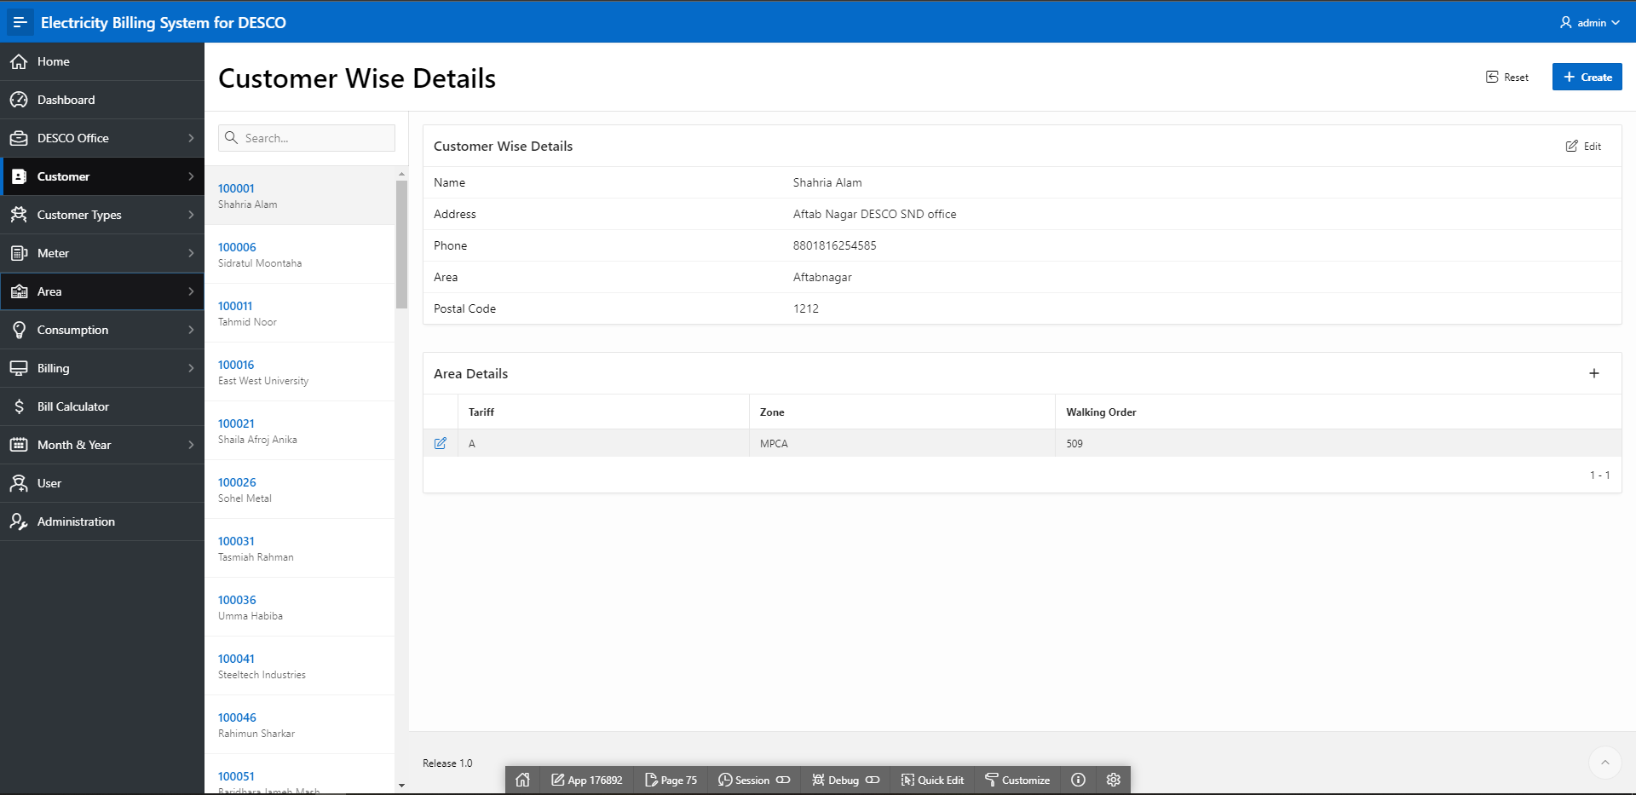

Fig 5.1: Customer Wise Details

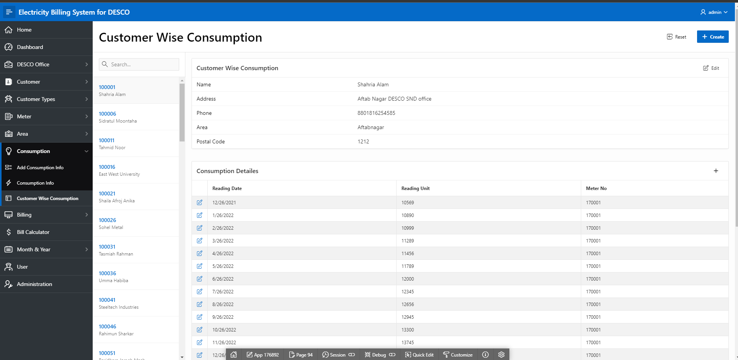

Fig 5.2: Customer Wise Consumption

# Reports based on Multi-Table and Aggregate Queries

|  |  |  |
| --- | --- | --- |
| Page Number and Name | Query Type | Report description |
| 107 – Bill calculator | Multi-table | The report gives the appropriate values |

# Parameterized Reports

|  |  |  |
| --- | --- | --- |
| Page Number and Name | Given Input | Report description |
| 107 - Bill Calculator | Customer ID, Year, Month | The report will show the total bill and all info according to the input. |

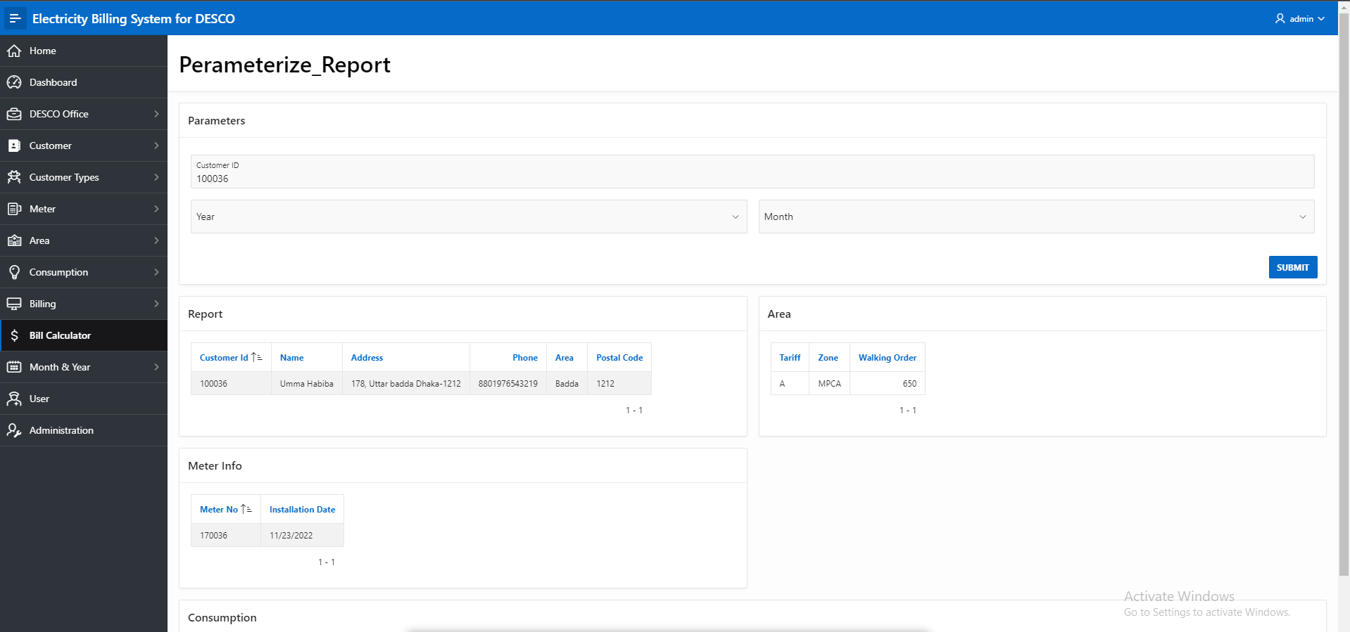

Fig 7.1: Bill Calculator

# Charts and Other Pages

|  |  |
| --- | --- |
| Page Number and Name | Chart description |
| 2 - Tariff VS Customers | This graph chart represent how many customers belong from a single tariff. |
| 2 - Year VS Users | This pie chart represent how many users started using DESCO meter in every year. |
| 2 - Area VS Customers | This graph chart represent how many customers belong from a single area. |
| 2 - Year VS Units | This line chart represent how many units spend in every year. |

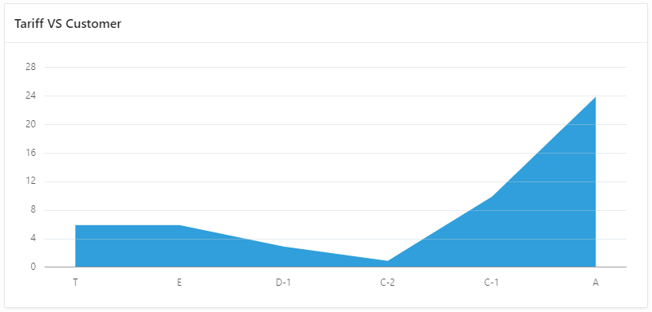

Fig 8.1: Tariff VS Customers

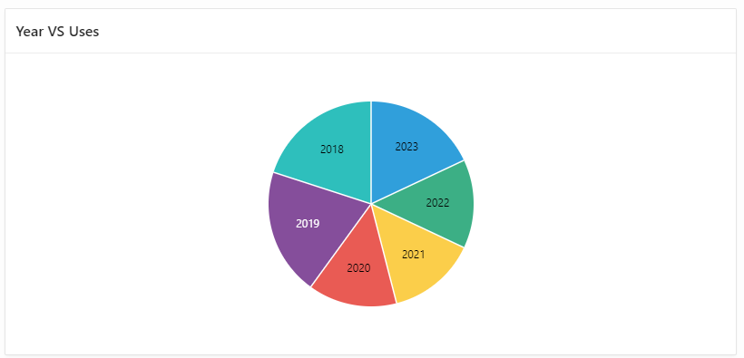

Fig 8.2: Year VS Users

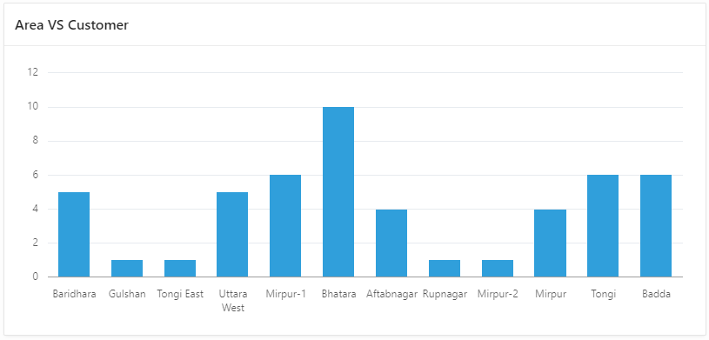

Fig 8.3: Area VS Customers

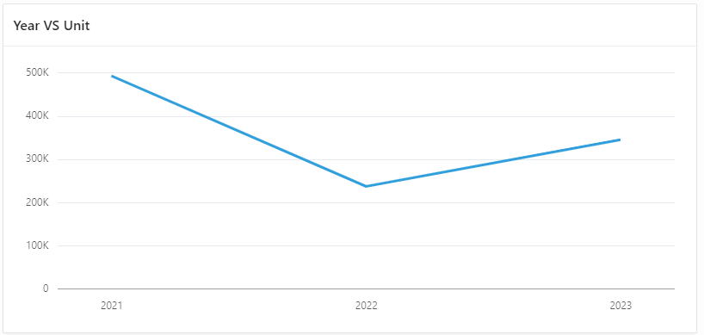

Fig 8.4: Year VS Units

# Authorization and User Role Assignment

**User Role Assignment**

|  |  |  |
| --- | --- | --- |
| User name | Password | Role |
| ADMIN | ADMIN | Administrator |
| GUEST | GUEST | Reader |

**Page-wise Authorization Information**

|  |  |
| --- | --- |
| Page number and name | Authorization Level |
| 1 - Home | Reader |
| 2 - Dashboard | Administrator |
| 3 – Add Customer Info | Administrator |
| 4 – Customer Info | Reader |
| 5 - Add Area Info | Administrator |
| 6 - Area Info | Administrator |
| 8 - Add Meter Info | Administrator |
| 9 - Meter Info | Administrator |
| 10 – Add Office Info | Administrator |
| 11 – Office Info | Reader |
| 18 - User | Administrator |
| 20 - Month Info | Administrator |
| 21 - Add month Info | Administrator |
| 22 - Year Info | Administrator |
| 23 - Add year info | Administrator |
| 24 - Add Customer Type | Administrator |
| 25 - Type Info | Administrator |
| 27 - Add Consumption Info | Administrator |
| 28 - Consumption info | Administrator |
| 73 - Add Billing Info | Administrator |
| 74 - Billing Info | Administrator |
| 75 - Customer Wise Details | Administrator |
| 94 - Customer Wise Consumption | Administrator |
| 107 - Bill Calculator | Reader |
| 10000 - Administration | Administrator |

# Concluding Remarks

This project help us to learn more about database. We have worked with real database which will help us in future to shine in life. Not only that we have implemented all knowledge in this project. So it was good experience.